Part 1
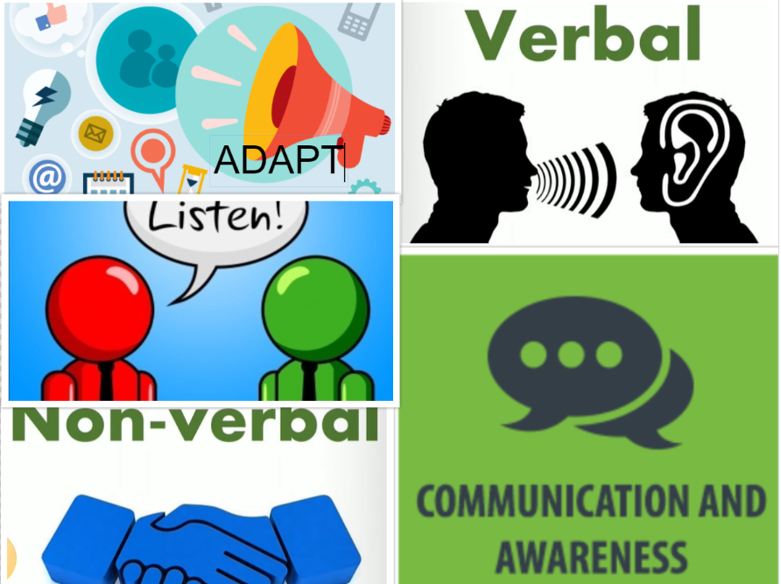
Part II
The five communication principles
Being aware of personal communication with others is one of the principles of communication. It includes having self-awareness about personal thoughts, emotions as well as behaviors. Awareness also includes being able to manage all these aspects when conversing with others to be able to successfully convey a personal message. A real-life example is when I engaged in a conversation to give me a pay rise after my dad had lost his job.
The effective use ad interpretation of verbal messages is also a major principle of communication. It includes a proper selection of the verbal symbols to use while communicating with others. It also includes being able to decode the messages from others carefully. An example of verbal communication in real-life is when I called my friend to congratulate him after successfully graduating from college. Words like “well done” and “keep up the good work” were used in the conversation.
Effective use of non-verbal messages and being able to interpret them is also a major principle in communication. The unspoken words can be expressed through symbols while communicating with others. These include the expression of emotions and feelings in communication through facial expressions or sign language. I have seen a friend fail in her interview as she failed to maintain eye contact which is a sign of a lack of confidence.
Listening is a key factor in communication. Listening attentively to others allows one to respond thoughtfully. The responses that one gives when communicating with others demonstrate whether one has understood the message. Attentive listening includes paying close attention to the non-verbal signs that one may use in their message. An example of poor listening in real-life is when I saw my professor being offended by a student who was on his phone during a special class announcement.
Appropriately adapting messages to the context of communication is also an important principle of communication. Adapting messages includes customizing the message to make it clearer based on the audience. There is a need to consider various characteristics of the audience like the social, cultural as well as age characteristics. An example of customizing message delivery is the provision of a document during a seminar to allow the audience to easily follow through with the speaker.

